**Group No: 54**

**Solar Based Peltier Refrigerator**

Dhananjay Shelke1, Mayur Shelke2, Tejas Kokane3, Nishant Chougule4*,Prof.R.R.Yenare5*

1234Students,Department of Mechanical, SKNCOE, SPPU, Pune

5Professor(Guide), Department of Mechanical, SKNCOE, SPPU, Pune

(*Corresponding author: )*

*Email:dhananjayshelke.skncoe.mech@gmail.com*

**ABSTRACT**

# In the recent years, we have many problem such as energy crises and environment degradation due to the increasing CO2 emission and ozone layer depletion has become the primarily concern to both developed and developing countries. Our paper utilizes the solar energy for its operation. Solar refrigeration using thermoelectric module is going to be one of the most cost effective, clean and environment friendly system. This paper does not need any kind of refrigerant and mechanical device like compressor, prime mover, etc for its operation. The main purpose of this project is to provide refrigeration to the remote areas where power supply is not possible.

# **Keywords: Carbon dioxide, Thermoelectric, Refrigeration, Peltier, Solar Panel**

## INTRODUCTION

Renewable & alternative non-conventional green energy technologies used for heat-pumping applications have shown real merits and received renewed interest in recent years especially in small-scale portable heating applications. Solar-driven thermoelectric heat pumping is one of these innovative technologies [1]. Solar energy is the most low cost, competition free, universal source of energy as sunshine's throughout. This energy can be converted into useful electrical energy using photovoltaic technology. Thermoelectric heating (or cooling) technology has received renewed interest recently due to its distinct features compared to conventional technologies, such as vapour-compression and electric heating (or cooling) systems. Thermoelectric (TE) modules are solid-state heat pumps (or refrigerators in case of cooling) that utilize the Peltier effect between the junctions of two semiconductors. The TE modules require a DC power supply so that the current flows through the TE module in order to cause heat to be transferred from one side of the TE module to other, thus creating a hot and cold side [2, 3].The main objective of the heating & cooling system service is to be suitable for use by the people who live in the remote areas of country where load- shading is a major problem. The system can also be used for remote parts of the world or outer conditions where electric power supply From last century till now refrigeration has been one of the most important factors of our daily life. The current tendency of the world is to look at renewable energy resources as a source of energy. This is done for the following two reasons; firstly, the lower quality of life due to air pollution; and, secondly, due to the pressure of the ever increasing world population puts on our natural energy resources. From these two facts comes the realization that the natural energy resources available will not last indefinitely. The basic idea is implementation of photovoltaic driven refrigerating system powered from direct current source or solar panel (when needed) with a battery bank. In 1821, the first important discovery relating to thermoelectricity occurred by German scientist Thomas Seebeck who found that an electric current would flow continuously in a closed circuit made up of two dissimilar metals, provided that the junctions of the metals were maintained at two different temperatures. Without actually comprehending the scientific basis for the discovery, See beck, falsely assumed that flowing heat produced the same effect as flowing electric current. Later, in 1834, while investigating the See beck Effect, a French watchmaker and part-time physicist, Jean Peltier found that there was an opposite phenomenon where by thermal energy could be absorbed at one dissimilar metal junction and discharged at the other junction when an electric current flows within the closed circuit. Afterwards, William Thomson described a relationship between See beck and Peltier Effect without any practical application. After studying some of the earlier thermoelectric work, Russian scientists in 1930s, inspired the development of practical thermoelectric modules based on modern semiconductor technology by replacing dissimilar metals with doped semiconductor material used in early experiments. The Seebeck, Peltier and Thomson effects, together with several other phenomena, form the basis of functional thermoelectric modules. Thermoelectric Refrigeration aims at providing cooling effect by using thermoelectric effects rather than the more prevalent conventional methods like those using the ‘vapour compression cycle’ or the ‘gas compression cycle’.

Refrigeration means removing the heat from the subject or space to lower temperature than of the surroundings. Thermoelectric cooling is on the way to eliminate heat from a medium or device by allowing an voltage of unchanged polarity to the junction between two dissimilar semiconductors or electrical conductors. Thermoelectric Refrigeration produce cooling effect by using thermoelectric effect (Peltier effect) rather than a common conventional methods. Conventional cooling systems used in refrigerators works by a compressor or by working fluid to transfer heat. But here we are avoiding all these methods to absorb Thermal energy. Semiconductor i.e thermoelectric cooler (also called as Peltier cooler) offer Several proffer advantages over the conventional systems. These are completely solid state devices, eleminating moving parts, this makes them uneven, quiet and reliable. There is no way for ozone depletion of CFCs chlorofluorocarbons, offering more ecologically responsible alternative to conventional refrigeration. They will be ultimate compact, than the compressor based systems. Explicit temperature (< ±0.1°C) are achieved by Peltier coolers. However, its efficiency is lower then the conventional regular refrigerators. Thus, these are used in suitable applications where their unique advantages override its low efficiency. But still some large scale applications are considered (on submarines and aircrafts), Peltier coolers aregenerally utilize where small size is needed and the cooling exact not too great, such as for cooling electronic devices.

1. **LITERATURE REVIEW**

1] *Awasti, M., & Mali, K. (2012).* Design and Development of Thermoelectric Refrigerator. International Journal of Mechanical Engineering and Robotics Research(Volume No. 3). The retention time achieved was 52 min with the designed module in this project. To achieve a higher retention time, another alternative was incorporated. This consists of the additional heater on a heat sink.

2] *Chetan Jangonda, K. P. (2016).* Review of various Applications of Thermoelectric Module. Thermoelectric cooling added a new dimension to cooling. It has a major impact on a conventional cooling system. It is compact in size, no frictional elements are present, no coolant is required and the weight of the system is low.

*3] D. Suman, p. H. (2020). Design and fabrication of thermoelectric refrigerator using peltier module*. The efficiency and life of the Peltier refrigerator are maximized by using these water pockets and the temperature was controllable by changing the input voltage and current so we can maintain the things at the required temperature. Finally, it has been recorded the minimum temperature i.e., 2°c.

## METHODOLOGY

A typical thermoelectric module is composed of two ceramic substrates that serve as a foundation and electrical insulation for P-type and N-type Bismuth Telluride dice that are connected electrically in series and thermally in parallel between the ceramics. The ceramics also serve as insulation between the module’s internal electrical elements and a heat sink that must be in contact with the hot side as well as an object against the cold side surface. Electrically conductive materials, usually copper pads attached to the ceramics, maintain the electrical connections inside the module. Solder is most commonly used at the connection joints to enhance the electrical connections and hold the module together. Most modules have and even number of P-type and N-type dice and one of each sharing an electrical interconnection is known as, "a couple". While both P-type and N-type materials are alloys of Bismuth and Tellurium, both have different free electron densities at the same temperature. P-type dice are composed of material having a deficiency of electrons while N-type has an excess of electrons. As current (Ampere) flows up and down through the module it attempts to establish a new equilibrium within the materials. The current treats the P-type material as a hot junction needing to be cooled and the N-type as a cold junction needing to be heated. Since the material is actually at the same temperature, the result is that the hot side becomes hotter while the cold side becomes colder. The direction of the current will determine if a particular die cools down or heat up. In short, reversing the polarity will switch the hot and cold sides.

Thermoelectric modules are solid-state heat pumps that operate on the Peltier effect (see definitions). A thermoelectric module consists of an array of p- and n-type semiconductor elements that are heavily doped with electrical carriers. The elements are arranged into array that is electrically connected in series but thermally connected in parallel. This array is then affixed to two ceramic substrates, one on each side of the elements (see figure below).

The heat transfer occurs as electrons flow through one pair of p- and n-type elements (often referred to as a "couple") within the thermoelectric module. The p-type semiconductor is doped with certain atoms that have fewer electrons than necessary to complete the atomic bonds within the crystal lattice. When a voltage is applied, there is a tendency for conduction electrons to complete the atomic bonds.

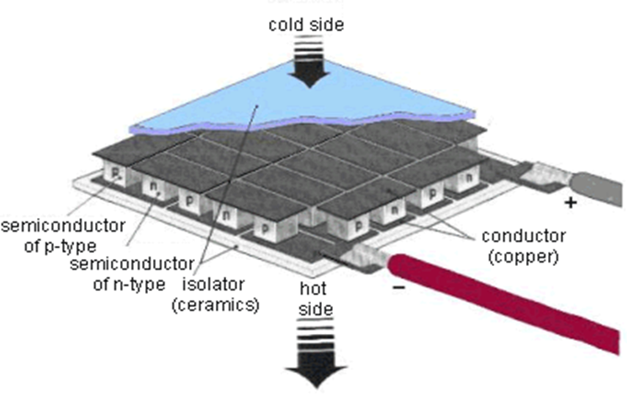

Fig 1. Peltier plate inner working

When conduction electrons do this, they leave “holes” which essentially are atoms within the crystal lattice that now have local positive charges. Electrons are then continually dropping in and being bumped out of the holes and moving on to the next available hole. In effect, it is the holes that are acting as the electrical carriers. Now, electrons move much more easily in the copper conductors but not so easily in these micro conductors. When electrons leave the p-type and enter into the copper on the cold-side, holes are created in the p-type as the electrons jump out to a higher energy level to match the energy level of the electrons already moving in the copper. The extra energy to create these holes comes by absorbing heat. Meanwhile, the newly created holes travel downwards to the copper on the hot side. Electrons from the hot-side copper move into the p-type and drop into the holes, releasing the excess energy in the form of heat.

The n-type semiconductor is doped with atoms that provide more electrons than necessary to complete the atomic bonds within the crystal lattice. When a voltage is applied, these extra electrons are easily moved into the conduction band. However, additional energy is required to get the n-type electrons to match the energy level of the incoming electrons from the cold-side copper.

1. **CONSTRUCTION OF REFRIGERATION SYSTEM**
2. Thermo-electric module

A thermo-electric module (TEM) is a solid state current device, which, if power is applied, move heat from the cold side to the hot side, acting as a heat exchanger. This direction of heat travel will be reversed if the current is reversed. It is a phenomenon that is opposite to the See beck effect. Combination of many pairs of p- and n-semiconductors allows creating cooling units - Peltier modules of relatively high power. A Peltier module consists of semiconductors mounted successively, which form p-n- and n-p-junctions. Each junction has a thermal contact with radiators. When switching on the current of the definite polarity, there forms a temperature difference between the radiators one of them warms up and works as a heat sink, and the other work as a refrigerator. A TE module is composed of two ceramic substrates that give foundation and also electrical insulation to p-type and n-type semiconductors. The TE module is composed of silicon bismuth semiconductor because this pair gives the highest COP. Specification,

1. Material used- Silicon - Bismuth

2. A = 0.04 x 0.04 = 0.0016 m2

3.Q max =33.3 watt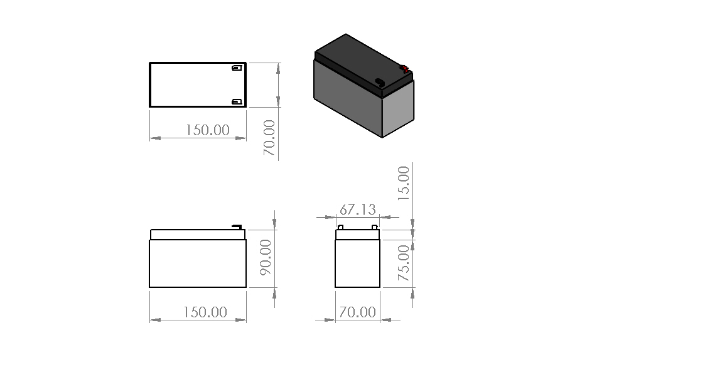

4.V max = 14.8 v dc

5. I max =3.6 amp

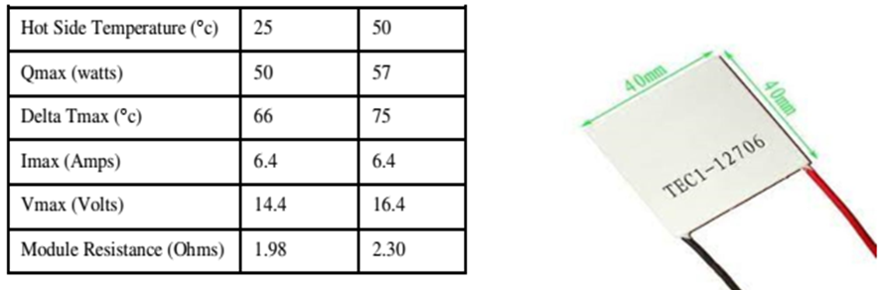

Fig 2. Peltier Plate

1. Battery

The battery is an electrochemical converting chemical energy into electrical energy. The main purpose of the battery is to provide a supply of current for operating the cranking motor and other electrical units.

Specification:

1. Voltage 12v

2. Current 7.2Ah

Fig 3. Battery

1. Solar Cell

Device which absorbs the sun’s energy in the form of photons, hence here we used two solar panel as a source and to charge the battery The direct conversion of solar energy is carried out into electrical energy by conversion of light or other electromagnetic radiation into electricity.

1. The dimensions of the panel are- Length – 48.5 cm, Width – 35 cm.

2. Number of sub-cells used is 72

3. Dimension of the sub-cells - Length – 4.8 cm, Width – 4 cm.

4. Maximum power is 20 W

5. Voltage is 17 V

6. Current is 1.16 A

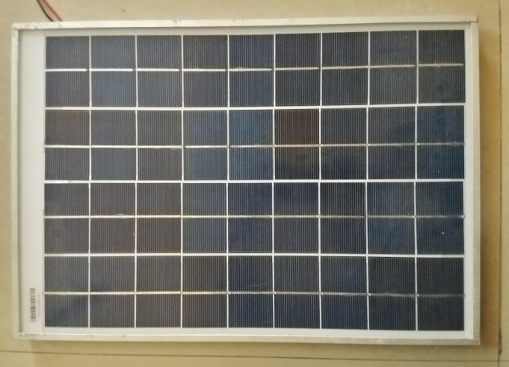

Fig 4. Solar Panel

1. Heat Sink with cooling fan

Heat sinks are generally used to transfer the thermal energy from the component i.e. Peltier device.we have used 3 cooling fans mounted on heat sink in either sides. The cooling fans in this refrigerator works on 12 V

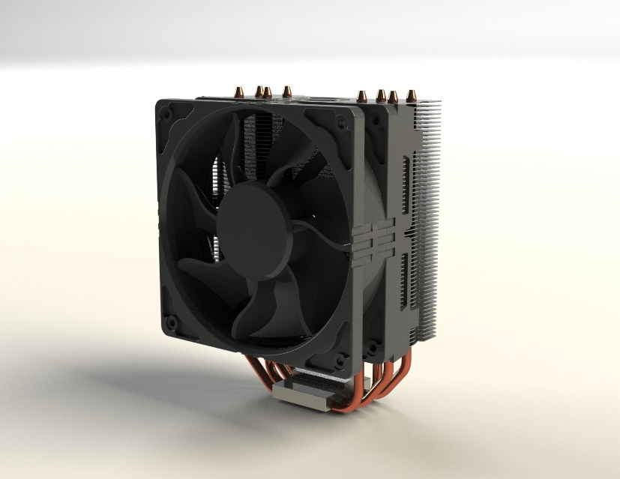

Fig 5. Heat Sink

1. Temperature indicator

It Indicates temperature and humidity present in the box and sensor is placed inside the cold chamber.

Fig 6. Temperature indicator

1. Refrigeration chamber

The chamber used is same as that of the chambers used in conventional refrigeration. The chamber can be of any volume, shape and size. For experimentation purposes the volume of the chambers is kept low.

We have used specific chamber and is as follows,

* 1. The size of the box is,
* Length – 45.7 cm,
* Width – 27.9 cm,
* Height - 33.5 cm.
  1. The power capacity is 84 W
  2. The capacity of cooling chamber is 18L.

Fig 7. Drafting

1. CAD Model

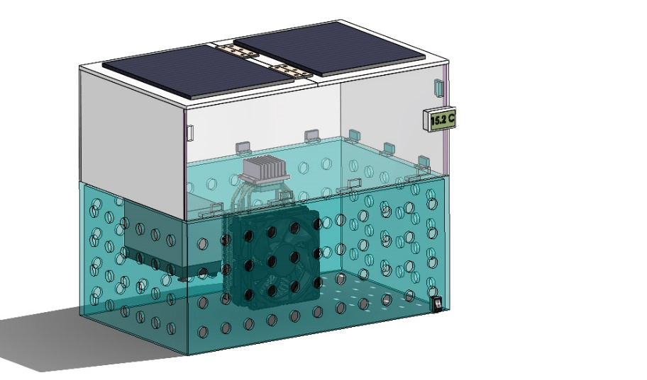

Fig 8. Final Setup

1. **DESIGN CALCULATIONS**

In this we calculate two types of load Heat absorbing load in the cabin and Heat rejection load through the outside Heat sink fan.

Volume = 450×150×275 = 18562500 millimeters3 = 18 Liter

First, we have to calculate how much amount of power is required to absorb the heat of a 18 liter size of volume box at 35°c outside Temperature.

So, there is a heat-absorbing load formula

Q = m*Cp*(Th- Tc).

so, we have to calculate Mass.

The amount of heat gained or lost by a sample (q) can be calculated using the equation q = mcΔT, where m is the mass of the sample, c is the specific heat, and ΔT is the temperature change

Mass = Density * volume = 1000*0.018 = 18 kg

Q = m*Cp*(Tamb -Tc)

= 18 x 4.186 (35 -15)

= 1506.96 kJ = 418 watt-hr or for 5 hr 418/5 = 83.6 watt

So, we required a total 83-watt heat-absorbing load in a 18 cubic meter volume box to reach 15°c in 83 watts we select 2 Peltier each Peltier would take 40 watts of load to cool up to 15°c

1. **WORKING**

The Refrigerator is provided power supply from a 12V DC 7.5 Ah battery which is charged by 12V Solar panel by converting solar energy into electrical energy. To start the Refrigerator, the power switch is turned on. Depending upon your position and requirement power supply will be decided i.e solar , AC power supply , or adapter/car lighter.

Now the Peltier Devices (TEC1-12706) generates cooling effect on inner side and heat is distributed on outer side. On the hot side of the Peltier device, heat sink along with cooling fan on both sides works to dissipate the heat from the peltier unit. The peltier module is arranged in proper insulation box and heat sink for get sufficient cooling effect. The cooling effect is created by the Peltier module is automatically sensed by Temperature sensor placed near the cooling side of the peltier device, and then the cooling rate along with humidity is digitally shown on the screen of Digital-meter. The battery of 12V DC 17 Ah is used to supply power to cooling fans and peltier device. To turn OFF the refrigerator, the switch can be turned off, which stops the refrigerator.

It is an equipment, which work on principle of conversion of solar energy into electrical energy. A solar cell is used to develop 14 V- & 0.71-amps current DC supply and 10 W.

This electrical energy is stored in a battery which is of 12 volts DC supply which then supplies the power to transformer.

The fan work as heat extractor, it removes heat from system and add to heat sink. During operation, DC current flows through the TEM causing heat to be transferred from one side of the TEC to the other, creating a cold and hot side.

## RESULTS AND DISCUSSION

The appropriate thermoelectrics for this application depends on three factors which are the hot surface temp (Th), cold surface temp (Tc), and heat load to be absorbed in the cold surface (Qc). The typical COP of the thermoelectric device between 0.4 and 0.7 for the single stage application. There are two thermal parameters which are basic to select a Peltier element which is the maximum cooling capacity Qmax and Temperature difference dT. It assumed an object with a heat load of QC = 10 W to 0°C to be cooler. The room temperature almost is 26°C and the heatsink temperature TS is expected to be between 5 to 15°C more than room temperature (5°C, so Ts=31°C). The temperature difference between the cold side and the hot side of the Peltier element dT is 31°C (Ts-To).It’s important to remember that it would be incorrect to calculate dT as the difference between ambient air temperature and desired object temperature. The performance vs. current graph, the maximum of the dT= 31°C curve located at a current of I/Imax = 0.42. In general, this ratio should not be higher than 0.7. Using factor for the current found in the heat pumped vs. current graph the value QC/Qmax = 0.16 for the given temperature difference dT = 31°C and relative current of 0.42. The Qmax for the Peltier element can be found as Qmax = QC /0.16= 10 W /0.16 = 62.5 W. The performance vs. current graph the COP can be found as 0.6 for the previously read out I/Imax which can help the Pel to be 16.667W. The Peltier element manufacturers offer a wide range of elements. In their product line, it looks for an element with a Qmax of 62.5W as it has a temperature difference of dT = 31°C. The Peltier element selected with Qmax = 62.5W, dT = 31 °C, Imax = 5.8 A and Vmax 15 V. The operating current and voltage calculated as,

I=Imax ×(I/Imax)=5.8A×0.42= 2.436 and V = Pel / I = 16.667W / 2.436A = 6.841 V. In order to find a heat sink for the Peltier element, it needs to know the required thermal resistance of the heat sink. In the heat rejected vs. current graph, it found Qh/Qmax=0.56. For our chosen current and dT. Thus, Qh=62.5 × 0.56 = 35 W. The heat sink thermal resistance: RthHS = ΔTHS/Qh = 5 / 35 = 0.1428 °C/W need a heat sink with a thermal resistance smaller than 0.1428°C/W .

Table 4. Test Results.

|  |  |  |
| --- | --- | --- |
| Sr No. | Time (min) | Cold temperature (0C) |
| 1 | 0 | 36 |
| 2 | 1 | 25 |
| 3 | 1.5 | 21 |
| 4 | 2 | 18 |
| 5 | 2.5 | 17 |
| 6 | 3 | 15 |
| 7 | 4 | 14 |
| 8 | 5 | 13 |
| 9 | 6 | 11.5 |
| 10 | 7 | 10 |

## Conclusions

The following concluding notes have been made based on the experimental study shows below:

* The lowest temperature reached to 10.6°C for the cooling while the highest temperature was obtained at 65°C for heating.
* Using solar based refrigerator as an alternative of using compressor operated refrigerator has many benefits such as saving the environment, cost, and health.
* The thermoelectric effect devices used as heat pumps, coolers, thermal energy sensors.
* The major challenge faced in Thermoelectric cooling is the lower coefficient of performance, exclusively in large capacity systems.
* Study different thermoelectric materials are essential to enhance the thermoelectric cooler coefficient of performance.

## References

1. International Journal of Engineering (IJE), Volume (5): Issue (1): 2011, Riffat SB. Xiaolima Thermo-electric: A Review of Present and Potential Applications. Applied Thermal Engg. 2003: 23: 913-35.
2. Bansal PK, Martin A, Comparative Study of Vapour Compression, Thermoelectric and Absorption Refrigerator – Rs. Int J Energy Res 2000; 24 (2): 93- 107.
3. En. Wikipedia.org/Thermo Electric Effect.
4. Angrist, S.W., 1971. Direct Energy Conversion (Allyn and Bacon, Inc., Boston, MA,).
5. “Solar Refrigeration Using the Peltier Effect”, by J.C.Swart, School of Electrical Engineering at the Cape Technicon.
6. Madsen, David A. (2004). Print Reading for Engineering and Manufacturing Technology. Delmar
7. Learning Blueprint Reading Series (2nd, Illustrated ed.). Cengage Learning. ISBN 1401851630.
8. Paris, Henri (2005). Modelling the Vibratory Drilling Process to Foresee Cutting Parameters.
9. CIRP Annals – Manufacturing Technologies. pp. 367–370. doi:10.1016/S0007 8506(07)60124-3 . ISSN 0007-8506
10. Orbital Drilling Goes Mainstream for the Dreamliner, Aerospace Engineering & Manufacturing, SAE International Publications, March 2009